Chapter Eight: Communicating in Teams and Organizations

QUESTION 1
You have been hired as a consultant to improve communication between engineering and marketing staff in a large high-technology company. Use the communication model and the four ways to improve that process to devise strategies to improve communication effectiveness among employees between these two work units.

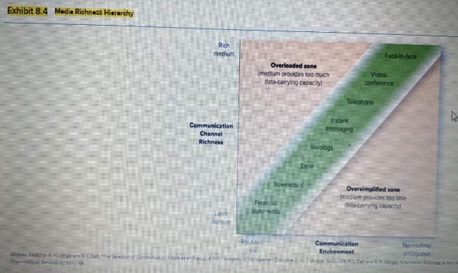
QUESTION 2

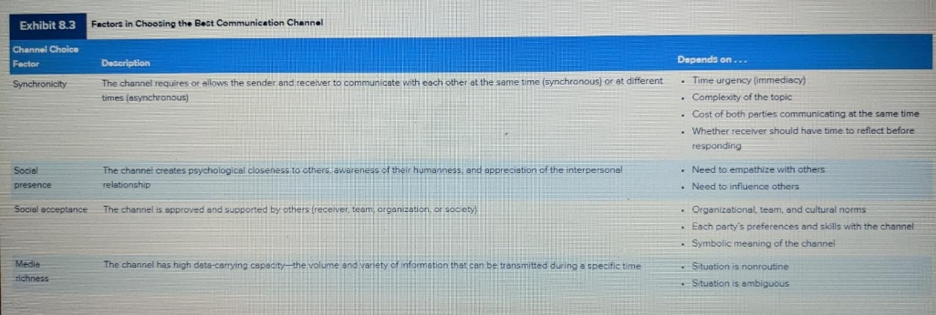

Look over the exhibit 8.3 on page 194 and the Media Richness hierarchy on page 196 (exhibit 8.4)
For each of the following identify which type of channels(s) you would choose to deliver the message and why.
You will first do this using exhibit 8.3, then repeat using exhibit 8.4

  - the agenda for an upcoming department meeting (for a department of 32 persons)
  - letting an employee know they are being laid off
  - an announcement for the annual holiday party
  - you need to solicit ideas for a new product being developed from staff in 6 offices around the U.S.
  - an employee just delivered her baby and is a new Mom
  - you need to clarify some points your assistant made at a previous meeting (your assistant is in a different office location)

QUESTION 3
Choose any two of the following and discuss how each could be useful for an organization. In other words, how would an organization use each in their communication strategies?
  - Wikis
  - Blogs
  - Facebook
  - Instagram
  - Twitter
  - YouTube
  - LinkedIn

QUESTION 4
Take the active listening self-assessment (link is in the module). Review your results. Then answer the following:

Active listening self-assessment Results

Avoiding Interruption
Score : 6 pts.
5-7Feedback : Your textbook described several dimensions of active listening. Five of these dimensions are estimated in this self-assessment: Avoiding Interruption, Maintaining Interest, Postponing Evaluation, Organizing Information and Showing Interest. Together, these five dimensions represent the total active listening score. Each subscale has a potential score ranging from 0 to 9 points; the total active listening score has a range from 0 to 45 points. Higher scores indicate that the person perceives that he or she has a higher level of each skill. The following graphs compare your results to the range of scores among a sample of over 200 MBA students.
Average score
People with high scores on this dimension have a strong tendency to let the speaker finish his or her statements before responding. Scores on this subscale range from 0 to 9. The average score among a sample of MBA students was 5.9.
Maintaining Interest
Score : 6 pts.
6-9Feedback : High score
People with high scores on this dimension have a strong tendency to remain focused and concentrate on what the speaker is saying even when the conversation is boring or the information is well known. Scores on this subscale range from 0 to 9. The average score among a sample of MBA students was 4.6.
Postponing Evaluation
Score : 8 pts.
7-9Feedback : High score
People with high scores on this dimension have a strong tendency to keep an open mind and avoid evaluating what the speaker is saying until the speaker has finished. Scores on this subscale range from 0 to 9. The average score among a sample of MBA students was 5.4.
Organising Information
Score : 1 pts.
0-4Feedback : Low score
People with high scores on this dimension have a strong tendency to actively organize the speaker’s ideas into meaningful categories. Scores on this subscale range from 0 to 9. The average score among a sample of MBA students was 6.4.
Showing Interest
Score : 5 pts.
5-6Feedback : Average score
People with high scores on this dimension have a strong tendency to use nonverbal gestures or brief verbal acknowledgements to demonstrate that they are paying attention to the speaker. Scores on this subscale range from 0 to 9. The average score among a sample of MBA students was 5.7.
Total score: 26 pts.

RANGE BASED FEEDBACK:
21-28 pts.
Feedback: Moderate active listening
People with high scores on this total score have a strong tendency to actively sense the sender’s signals, evaluate them accurately and respond appropriately. Scores on this active listening total score range from 0 to 45. The average score among a sample of MBA students was 27.9.

1. What are the 3 areas of active listening? What were your scores?
2. Are a good active listener? Why or why not?
3. What could you do to better improve your active listening skills?

QUESTION 5
A student copy/pastes information from a website into a term paper, but does not cite the source. The professor accuses the student of plagiarism and gives the student an F for the assignment. The student maintains that the internet is open, and information on the web is available to all for free. So how could this be plagiarism?
Whose side are you on? Explain why.
QUESTION 6
For this discussion please respond to the following. You may want to Google the difference between slang and jargon.
1. Share with you classmates five examples of jargon. Identify the industry the terms apply to and what each term means.
2. Share with your classmates five examples of cross-cultural marketing translation mistakes. Explain each.
3. Every generation has it's own unique slang terms. Your ancient professor is trying to understand current slang. Share five examples of slang being used by today's teens or college students. Explain each.
4. Is communicating with others easy? Explain.

